CI CD LAB EXPERIMENT -1

(BY: AMAN TYAGI)

Aim: Installation of Jenkins and Execution of a simple job in Jenkins.

## Installation:

## Download Jenkins war file from [https://www.jenkins.io/download](https://www.jenkins.io/download/)/

## Open the command prompt as admin.

## Traverse to the directory containing the jenkins.war file

## Run the command :

## java -jar jenkins.war

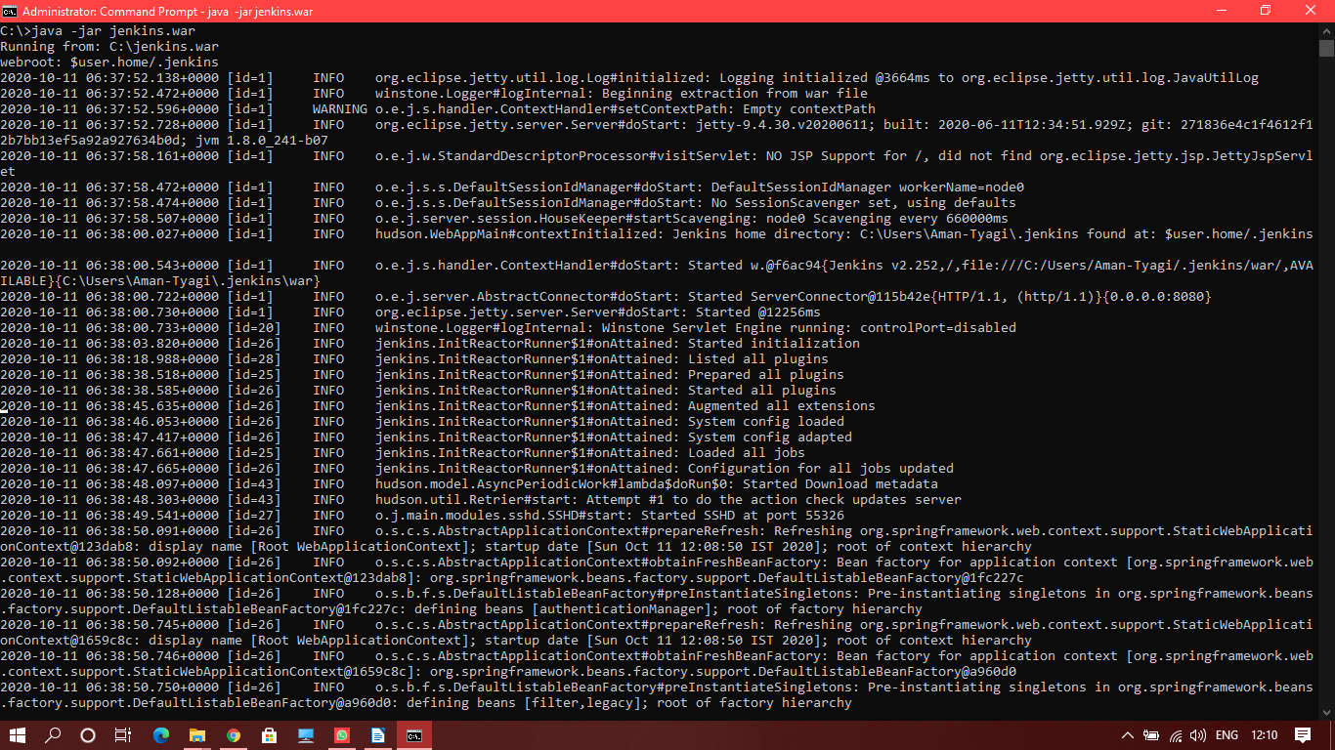

1. You will see an output “Jenkins is fully up and running”
2. Open the web browser.
3. Go to localhost:8080 (Default port of jenkins)
4. Log in into the Jenkins dashboard (You can change the username and password according to you)

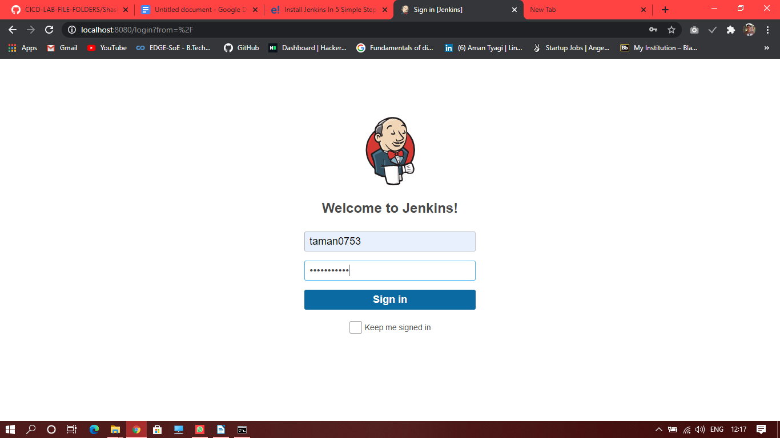

Jenkins Dashboard:

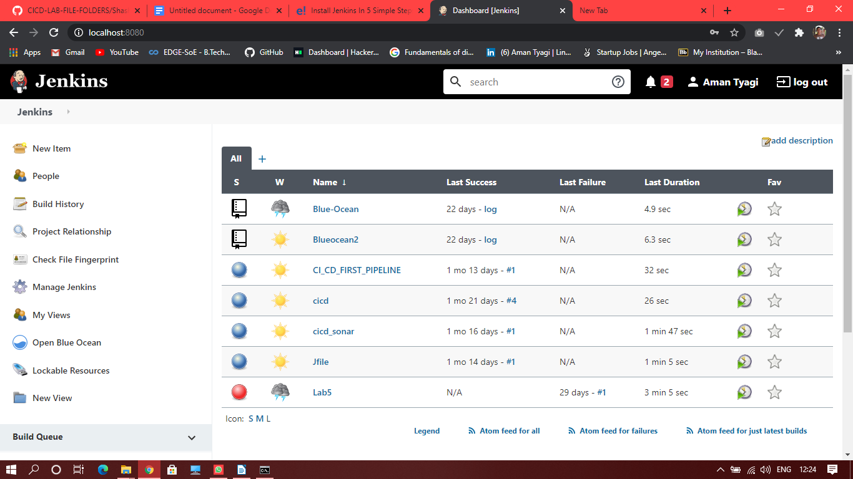

Run a simple job in Jenkins:

1. You will need to add the path of JDK and Maven to Jenkins.
2. Go to Manage Jenkins >> Global tool configuration

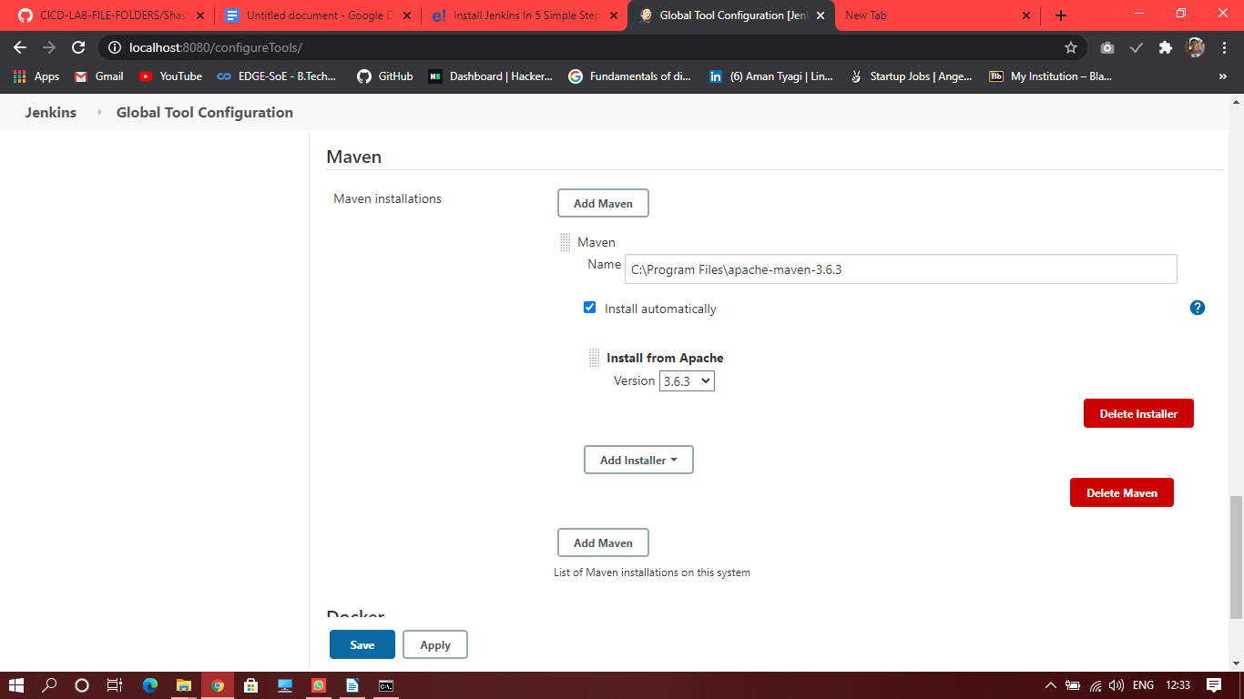

Similarly add JDK to Jenkins.

1. Go Manage jenkins >> Manage Plugin
2. Search maven plugin in the available plugins. Install the plugin

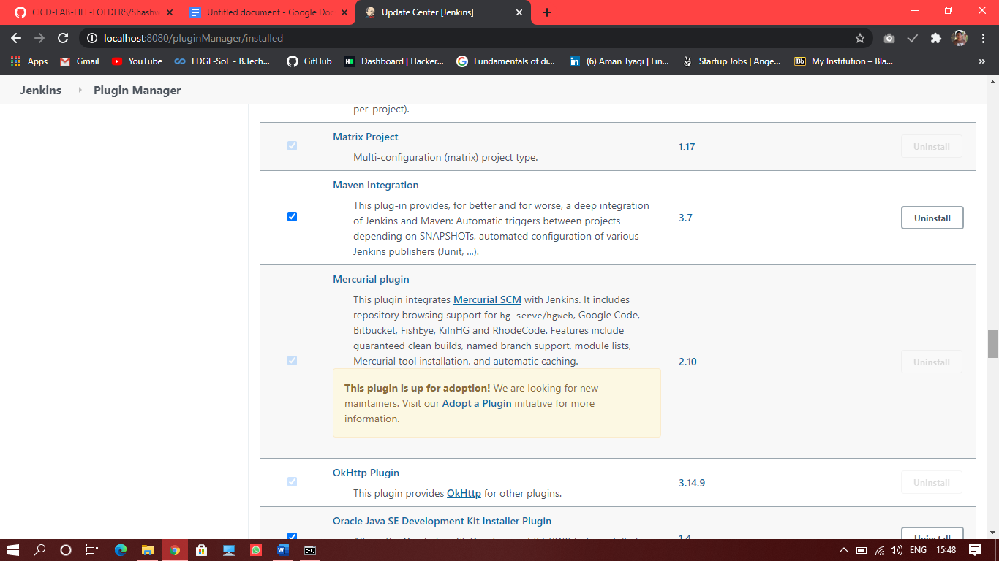

1. Create a new item from dashboard
2. Select maven project and give it a name.
3. Specify the location of pom.xml location.
4. Specify the project directory and your job should be like

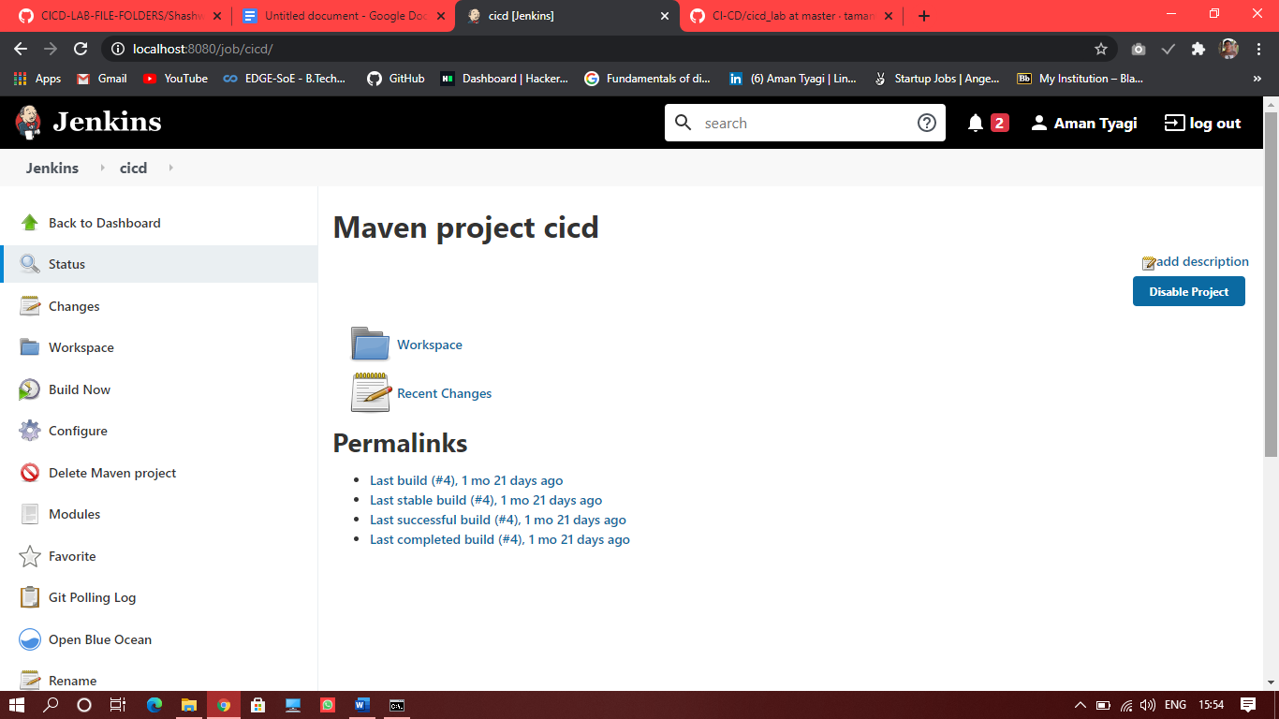

1. Click build now
2. If everything is fine you will see build success at console output.



 